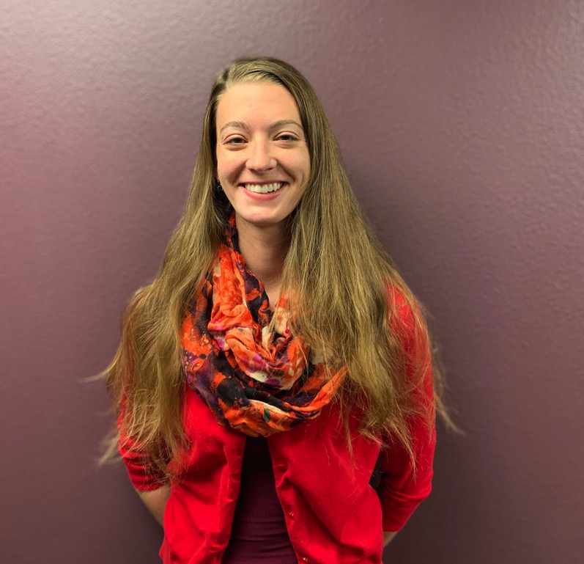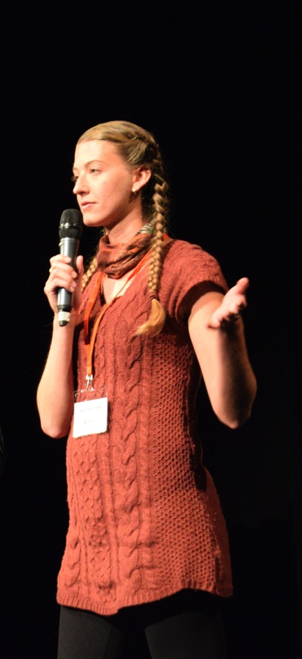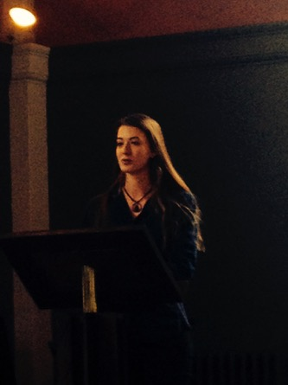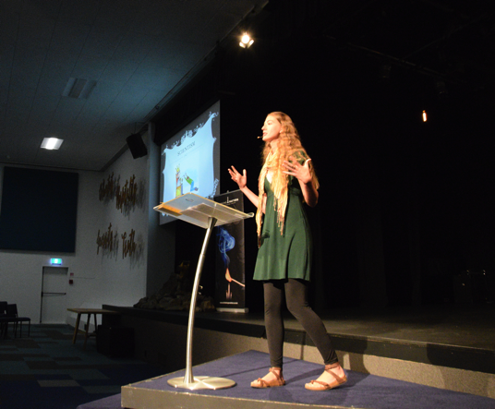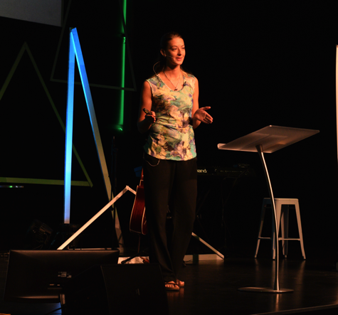

Contact Information:

[xandra.carroll@gmail.com](mailto:xandra.carroll@gmail.com)

xandracarrollministries.com

720.645.8658

B.S. Biological Science; Colorado State University, USA

C.T.P.S. Apologetics; Oxford University, UK

M.Sci. Conservation Biology: Victoria University, NZ

Alexandra Lee Carroll

Speaker Bio

**Personal Background**

Alexandra was born in California, raised in Colorado, and has spent much of her adulthood travelling the world. She was raised in a Christian home, but in high school she began asking questions about how we understand the reality of God. She later became the leader of her high school Bible Club. At university she witnessed firsthand the wonderful tool apologetics can be for evangelism. She began listening to apologetic podcasts online and sharing her faith with others more openly. She went on train leaders in Youth Ministry in Strasbourg (France), later moving to Jiujiang (China) and finally made her way to Oxford (United Kingdom) where she pursued graduate studies in Christian Apologetics. She toured Goa (India) speaking to church youth groups and to women recovered from human trafficking on the topic of human value. She currently resides in Golden, Colorado.

**Professional Background**

Alexandra took her first paid speaking appointment in America at the age of 26. She has been invited to speak on topics including paleontology, biology, cosmology, philosophy, human value, creation, the biblical view of women, heaven, hell, and others. She has a background in science but is also conversant in philosophy, having studied philosophy and theology at Wycliffe Hall, Oxford. Aside from speaking she has also led several training/discussion groups for local churches. Her technical background includes both laboratory and field research. She has experience teaching English from primary to university ages. She was a botany tutor at Colorado State University. She has a great appreciation for film and worked as a projectionist for years until the projectors went digital. She hopes to pursue a PhD in Restoration Ecology at Victoria University in New Zealand.

“We have good reasons for believing. Those reasons may not be confined to a test tube, but they are valid.”

*-Alexandra Carroll*

# **About the Speaker**

“The Holy Spirit is the life-blood of apologetics, and Scripture is its backbone.”

*-Alexandra Carroll*

**Affiliations**

*Ravi Zacharias International Ministries*

Guest Speaker

*Ratio Christi*

Director; Colorado School of Mines

Speaker’s Bureau

*Oxford Centre for Christian Apologetics*

Alumni

Speaker’s Bureau

*Oxford University Scientific Society*

Lifetime Member

**Prices**

In the event of travel, all travel expenses must be covered; lodgings (either home or hotel) will be expected. Usually an honorarium of at least $100 per speaking event (not per conference) is included.

**Examples of Speaking Engagements**

*The Philosophy of Science* (March 2014) Kent College, Canterbury, England

*The New Atheism* (April 2015) Portland State University, Portland, USA

*Feathered Dinosaurs: the Fee Fi Fo Fum Model* (July 2015) Denver, USA

*A Broken Pot; Human Value in a World of Karma* (August 2015) Goa, India

*Can a Scientist Believe in the Resurrection?*  (January 2016) McGill University,

Montreal, Canada

*Finding God in Science* (April 2016) Arizona State University, Arizona, USA

*Conversations about Conservation* (April 2017) Auckland, New Zealand

*What’s Unnatural about Naturalism?* (May 2017) Christchurch, New Zealand

*Are Science and Faith contradictory?* (July 2018) Universidad Pedagógica

Nacional, San Pedro Sula, Honduras